**PWSkills Assignment 05**

**(Done By: Sunandan Sharma)**

**1.**

**Code:**

**(HTML)**

<!DOCTYPE html>

<html lang="en">

<head>

    <meta charset="UTF-8">

    <meta name="viewport" content="width=device-width, initial-scale=1.0">

    <title>Relative Positioning Example</title>

    <link rel="stylesheet" href="Style_1.css">

</head>

<body>

    <div class="square" id="boxA">

        <span>A</span>

    </div>

    <div class="square" id="boxB">

        <span>B</span>

    </div>

    <div class="square" id="boxC">

        <span>C</span>

    </div>

    <div class="square" id="boxD">

        <span>D</span>

    </div>

    <div class="square" id="boxE">

        <span>E</span>

    </div>

</body>

</html>

**(CSS)**

body {

    margin: 0;

    padding: 0;

    display: flex;

    justify-content: center;

    align-items: center;

    height: 100vh; /* Ensure full viewport height for centering */

    position: relative; /* Ensure body serves as a positioning context for absolute children */

}

.square {

    width: 50px;

    height: 50px;

    background-color: aquamarine; /* Change color as desired */

    display: flex;

    justify-content: center;

    align-items: center;

    position: absolute;

}

#boxA {

    left: 200px; /* 200px from the left of the viewport */

    top: 200px; /* 200px from the top of the viewport */

}

#boxB {

    left: calc(200px - 30px); /* 30px left relative to the center of box A */

    top: calc(200px - 30px); /* 30px upward relative to the center of box A */

    border: 1em;

    z-index: 1000;

}

#boxC {

    left: calc(200px + 30px); /* 30px left relative to the center of box A */

    top: calc(200px - 30px); /* 30px upward relative to the center of box A */

    border: 1em;

    z-index: 1000;

}

#boxD {

    left: calc(200px - 30px); /* 30px left relative to the center of box A */

    top: calc(200px + 30px); /* 30px upward relative to the center of box A */

    border: 1em;

    z-index: 1000;

}

#boxE {

    left: calc(200px + 30px); /* 30px left relative to the center of box A */

    top: calc(200px + 30px); /* 30px upward relative to the center of box A */

    border: 1em;

    z-index: 1000;

}

**Code GitHub link (HTML):** [**Assignment 05- Q1 HTML Code Link**](https://github.com/Sunandanshrm/Web-Development/blob/master/Frontend/PwSkills/Assignment%2005/index_1.html)

**Code GitHub link (CSS):** **[Assignment 05 - Q1 CSS Code Link](https://github.com/Sunandanshrm/Web-Development/blob/master/Frontend/PwSkills/Assignment%2005/Style_1.css)**

**The Output:**

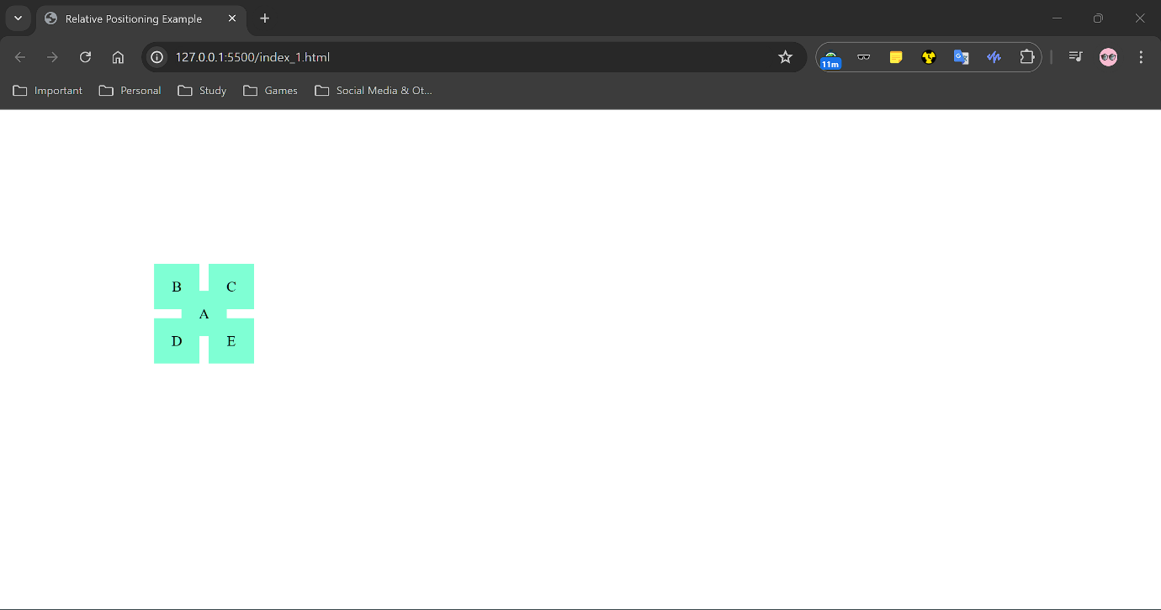

**2.**

|  |  |
| --- | --- |
| **Absolute Positioning** | **Relative Positioning** |
| With absolute positioning, an  element is positioned relative  to its nearest positioned  ancestor | In relative positioning, elements can be moved up,  down, left, or right from its  normal position. |
| Normal Document Flow is broken | Normal Document Flow is unbroken while positioning new element on the page |
| No space is left in the original position | The element will leave position in its original position and other contents will not be adjusted to fit any gap |

**3.**

**Code:**

**(HTML)**

<!DOCTYPE html>

<html lang="en">

<head>

    <meta charset="UTF-8">

    <meta name="viewport" content="width=device-width, initial-scale=1.0">

    <title>Float Card Example</title>

    <link rel="stylesheet" href="Style_3.css">

</head>

<body>

    <div class="card">

        <div class="content">

            <h1>The Earth !!!</h1>

            <p>Nature is Earth's masterpiece, a symphony of life composed through millennia. Its landscapes whisper tales of ancient mountains, winding rivers, and flourishing forests, reminding us of the planet's boundless beauty. From delicate petals to towering redwoods, nature's artistry stirs awe and reconnects us to the essence of existence. Nature is Earth's masterpiece, a symphony of life composed through millennia. Its landscapes whisper tales of ancient mountains, winding rivers, and flourishing forests.</p>

        </div>

        <div class="image">

            <img src="Assets/image_3_Assets.jpg" alt="Placeholder Image">

        </div>

    </div>

</body>

</html>

**(CSS)**

body {

    font-family: Arial, sans-serif;

    margin: 0;

    padding: 0;

    background-color: #f0f0f0;

}

.card {

    width: 900px;

    background-color: #f5f5dc;

    margin: 20px auto;

    padding: 15px;

    border: 1px solid #ccc;

    overflow: hidden; /* Clear the floats */

}

.content {

    float: left;

    width: 60%; /* Adjust width as needed */

}

.image {

    float: right;

    width: 30%; /* Adjust width as needed */

    text-align: right; /* Center align the image */

}

.image img {

    max-width: 100%;

    height: auto;

}

**Code GitHub link (HTML):** [**Assignment 05- Q3 HTML Code Link**](https://github.com/Sunandanshrm/Web-Development/blob/master/Frontend/PwSkills/Assignment%2005/index_3.html)

**Code GitHub link (CSS):** [**Assignment 05 – Q3 CSS Code Link**](https://github.com/Sunandanshrm/Web-Development/blob/master/Frontend/PwSkills/Assignment%2005/Style_3.css)

**The Output:**

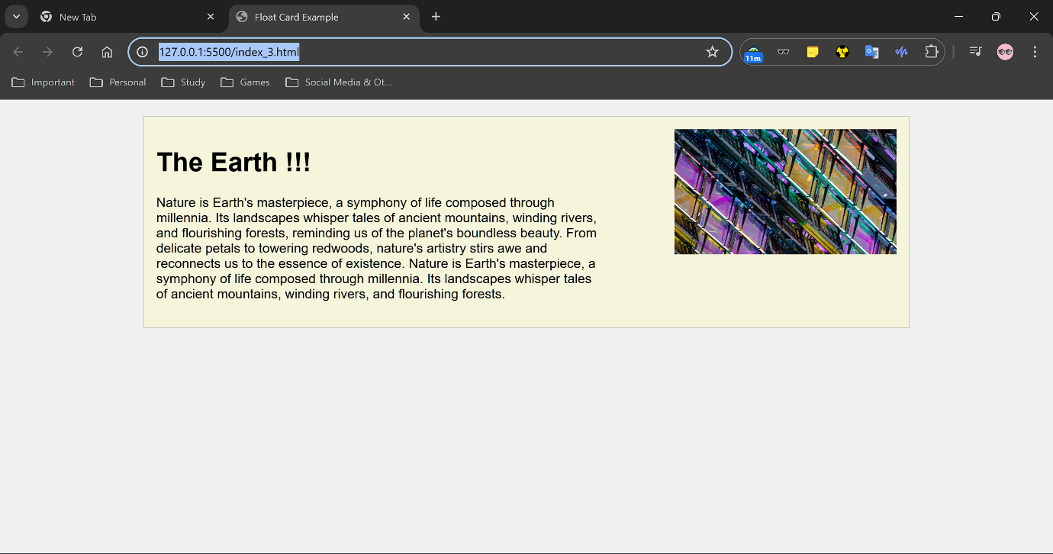

**4.**

**Code:**

**(HTML)**

<!DOCTYPE html>

<html lang="en">

<head>

    <meta charset="UTF-8">

    <meta name="viewport" content="width=device-width, initial-scale=1.0">

    <title>Sticky Header Example</title>

    <link rel="stylesheet" href="Style_4.css">

</head>

<body>

    <header class="sticky-header">

        <h1 class="logo">Logo</h1>

        <nav>

            <ul>

                <li><a href="#">Home</a></li>

                <li><a href="#">Pricing</a></li>

                <li><a href="#">Contacts</a></li>

                <li><a href="#">Terms and Conditions</a></li>

                <li><a href="#">Get Started</a></li>

            </ul>

        </nav>

    </header>

    <main>

        <section>

            <h2>Heading 1</h2>

            <p>Lorem ipsum dolor sit amet, consectetur adipiscing elit. Nullam in viverra nulla. Etiam bibendum purus non mauris pharetra, sed sagittis est efficitur. Proin ut magna non metus accumsan egestas.Lorem ipsum dolor sit amet, consectetur adipiscing elit. Nullam in viverra nulla. Etiam bibendum purus non mauris pharetra, sed sagittis est efficitur. Proin ut magna non metus accumsan egestas.Lorem ipsum dolor sit amet, consectetur adipiscing elit. Nullam in viverra nulla. Etiam bibendum purus non mauris pharetra, sed sagittis est efficitur. Proin ut magna non metus accumsan egestas.Lorem ipsum dolor sit amet, consectetur adipiscing elit. Nullam in viverra nulla. Etiam bibendum purus non mauris pharetra, sed sagittis est efficitur. Proin ut magna non metus accumsan egestas.</p>

        </section>

        <section>

            <h2>Heading 2</h2>

            <p>Lorem ipsum dolor sit amet, consectetur adipiscing elit. Nullam in viverra nulla. Etiam bibendum purus non mauris pharetra, sed sagittis est efficitur. Proin ut magna non metus accumsan egestas.Lorem ipsum dolor sit amet, consectetur adipiscing elit. Nullam in viverra nulla. Etiam bibendum purus non mauris pharetra, sed sagittis est efficitur. Proin ut magna non metus accumsan egestas.Lorem ipsum dolor sit amet, consectetur adipiscing elit. Nullam in viverra nulla. Etiam bibendum purus non mauris pharetra, sed sagittis est efficitur. Proin ut magna non metus accumsan egestas.Lorem ipsum dolor sit amet, consectetur adipiscing elit. Nullam in viverra nulla. Etiam bibendum purus non mauris pharetra, sed sagittis est efficitur. Proin ut magna non metus accumsan egestas.</p>

        </section>

        <section>

            <h2>Heading 3</h2>

            <p>Lorem ipsum dolor sit amet, consectetur adipiscing elit. Nullam in viverra nulla. Etiam bibendum purus non mauris pharetra, sed sagittis est efficitur. Proin ut magna non metus accumsan egestas.Lorem ipsum dolor sit amet, consectetur adipiscing elit. Nullam in viverra nulla. Etiam bibendum purus non mauris pharetra, sed sagittis est efficitur. Proin ut magna non metus accumsan egestas.Lorem ipsum dolor sit amet, consectetur adipiscing elit. Nullam in viverra nulla. Etiam bibendum purus non mauris pharetra, sed sagittis est efficitur. Proin ut magna non metus accumsan egestas.Lorem ipsum dolor sit amet, consectetur adipiscing elit. Nullam in viverra nulla. Etiam bibendum purus non mauris pharetra, sed sagittis est efficitur. Proin ut magna non metus accumsan egestas.Lorem ipsum dolor sit amet, consectetur adipiscing elit. Nullam in viverra nulla. Etiam bibendum purus non mauris pharetra, sed sagittis est efficitur. Proin ut magna non metus accumsan egestas.</p>

        </section>

    </main>

</body>

</html>

**(CSS)**

body {

    margin: 0;

    padding: 0;

    font-family: Arial, sans-serif;

}

header {

    display: flex;

    align-items: center;

    width: 100%;

    background-color: #333;

    color: white;

    padding: 10px 20px;

    position: fixed;

    top: 0;

    left: 0;

    z-index: 1000; /* Ensures the header stays on top of other content */

}

.logo {

    font-size: 24px;

    font-weight: bold;

    margin: 0;

}

header nav {

    margin-left: 500px; /* Add margin-left to shift the nav links to the left */

}

header ul {

    list-style: none;

    padding: 0;

    margin: 0;

    display: flex; /* Ensure the nav links are aligned to the start */

}

header li {

    margin: 0 15px;

}

header a {

    color: white;

    text-decoration: none;

    padding: 5px 10px;

    opacity: 0.3; /* Adds a transition effect for the opacity change */

}

header a:hover {

    opacity: 1; /* Changes opacity to 70% on hover */

    background-color: #575757;

    border-radius: 5px;

}

header li:last-child a {

    color: gold;

    border: 2px solid gold;

    border-radius: 5px;

    padding: 3px 8px; /* Adjust padding to account for border */

}

main {

    margin-top: 60px; /* Add space to avoid overlap with fixed header */

    padding: 20px;

}

section {

    margin-bottom: 50px;

}

section h2 {

    margin-top: 0;

}

**Code GitHub link (HTML):** [**Assignment 05- Q4 HTML Code Link**](https://github.com/Sunandanshrm/Web-Development/blob/master/Frontend/PwSkills/Assignment%2005/index_4.html)

**Code GitHub link (CSS):** [**Assignment 05 – Q4 CSS Code Link**](https://github.com/Sunandanshrm/Web-Development/blob/master/Frontend/PwSkills/Assignment%2005/Style_4.css)

**The Output:** [**Assignment 05 – Q4 Output Link**](https://drive.google.com/file/d/1PXrrayeDleOrYNClJ0X-foek04pUhtT3/view?usp=drive_link)

**5.** Here is a code which shows the use of Z-index. Z-index is a Cascading Style Sheets (eCSS) property that controls the stacking order of overlapping HTML elements on a page.

**Code:**

**(HTML)**

<!DOCTYPE html>

<html lang="en">

<head>

    <meta charset="UTF-8">

    <meta name="viewport" content="width=device-width, initial-scale=1.0">

    <title>Z-Index Example</title>

    <link rel="stylesheet" href="Style_5.css">

</head>

<!-- This is a HTML Code to show an example of Z-index-->

<body>

    <div class="box box1"></div>

    <div class="box box2"></div>

    <div class="box box3"></div>

</body>

</html>

**(CSS)**

/*Elements with a higher z-index value appear in front of elements with a lower z-index value*/

body {

    display: flex;

    justify-content: center;

    align-items: center;

    height: 100vh;

    margin: 0;

    background-color: #f0f0f0;

    position: relative;

}

.box {

    width: 150px;

    height: 150px;

    color: white;

    display: flex;

    justify-content: center;

    align-items: center;

    position: absolute;

    font-size: 20px;

    font-family: Arial, sans-serif;

}

.box1 {

    background-color: red;

    top: 50px;

    left: 50px;

    z-index: 3;/* The box will be at the top*/

}

.box2 {

    background-color: green;

    top: 100px;

    left: 100px;

    z-index: 2;/* The box will be at the middle*/

}

.box3 {

    background-color: blue;

    top: 150px;

    left: 150px;

    z-index: 1;/* The box will be at the bottom*/

}

**Code GitHub link (HTML):** [**Assignment 05- Q5 HTML Code Link**](https://github.com/Sunandanshrm/Web-Development/blob/master/Frontend/PwSkills/Assignment%2005/index_5.html)

**Code GitHub link (CSS):** [**Assignment 05 – Q5 CSS Code Link**](https://github.com/Sunandanshrm/Web-Development/blob/master/Frontend/PwSkills/Assignment%2005/Style_5.css)

**The Output:**

